Permanent Orders (W8AMAA) 056-01 1 October 2025

AWARD OF THE OGLETHORPE DISTINGUISHED SERVICE MEDAL

Under the provisions of Georgia Code, Title 38, § 38-2-283 (Military, Emergency Management, and Veterans Affairs) and Georgia Department of Defense Regulation 600-1 (The Georgia Military Awards Program), for meritorious act, achievement, or service rendered to the state of Georgia, this military decoration is presented to:

LIETENANT COLONEL SARAH WITHANH
JOINT FORCE HEADQUARTERS
GEORGIA ARMY NATIONAL GUARD

For exceptionally meritorious service through 25 years of outstanding service, culminating as the Director of the Joint Staff. Lieutenant Colonel Sarah Withanh executed every task with perfection and professionalism; she made the Joint Staff better for being there. Her expert negotiations with an attaché of the government of Spain helped the Governor of Georgia broker a trade deal through the port city of Savannah.

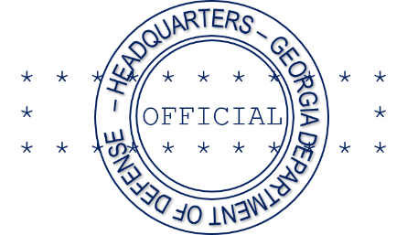
These accomplishments, in keeping with the finest traditions of military service, reflect great credit upon herself, the Georgia Department of Defense, and the state of Georgia.

BY ORDER OF THE GOVERNOR

STEPHEN M. JOHNSTON
COL, IN, GAARNG
Deputy Chief of Staff, Personnel

DISTRIBUTION:
Indiv (1)
File (1)

